OAK RIDGE FOX HUNT CLUB ~ SPRING HUNTER PACE 2021

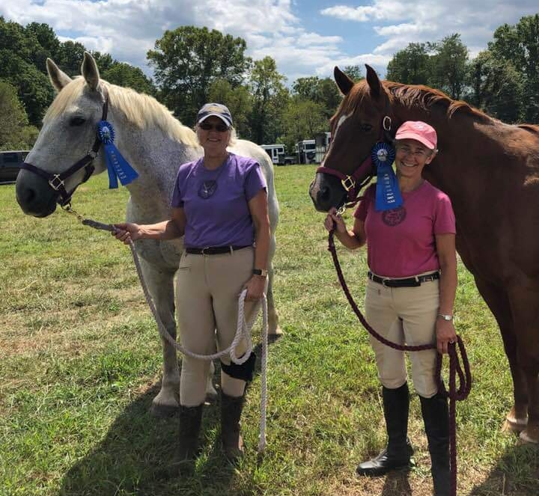
Saturday, May 8, 2021, 9 AM to Noon
TeaTime Farm
1295 Greenfield RD, Afton, VA

The Hunter Pace will benefit the Hounds of the OAK RIDGE FOX HUNT CLUB
The members of Oak Ridge are planning an inviting course that will allow you to enjoy the beautiful countryside at TeaTime Farm. The course is approximately 7 miles with 20-25 jumping efforts. There are go-arounds for those who do not wish to jump. All disciplines are welcome. Teams will consist of 2 or 3 riders.
Divisions:
First Flight / Full Cry: For those seeking a fast pace and the thrill of fox hunting. Jumps under 3'.

Second Flight: For riders who enjoy a challenging ride. Jumps are optional.
Hill Topper/Trail: A relaxed and leisurely ride through our hunt country. No jumps.

Junior: At least one member of the team must be under 18 years old. Judged at Second Flight Pace.
Times: Ride start times are between 9:00 AM and 12 Noon.
Fees: $40 adult & $25 junior (17 & under). Enter online at https://orfhc.square.site/
You may also register by sending the entry form, signed release, coggins, and a check made payable to Oak Ridge Fox Hunt Club. Forms are available at www.oakridgefoxhuntclub.com
Mail to Rebecca Birnbaum, 11254 Rockfish Valley Highway, Afton, VA 22920.
For information, contact Becky at beckybirnbaum@gmail.com

