Oak Ridge Fox Hunt Club
Poker Ride
April 10, 2021  Wood Ridge Farm Brewery  165 Old Ridge RD.  Lovingston, VA  10 AM to 1 PM | 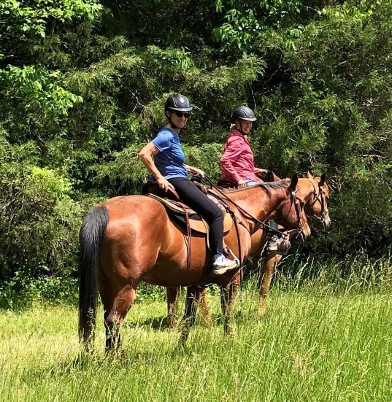
Join in on the search for poker chips while
riding wooded trails and fields behind
Wood Ridge Farm Brewery.
Turn in your chips for five cards.
The top poker hands win cash prizes.
All disciplines are welcome.

Entry fee is $40 for adults, $25 for juniors.
Purchase lunch at the Brewery after you ride.
Enter online at https://orfhc.square.site/

For information, contact Mary Tousignant
at mary_tousignant@comcast.net

Visit www.oakridgefoxhuntclub.com
for entries and releases
Proof of Negative Coggins is required.
Boots and helmets are required.

