Oak Ridge Fox Hunt Club
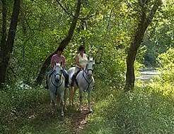
Judged Pleasure Ride
June 6, 2021
Teatime Farm
1295 Greenfield Rd
Afton, VA
9 AM to Noon

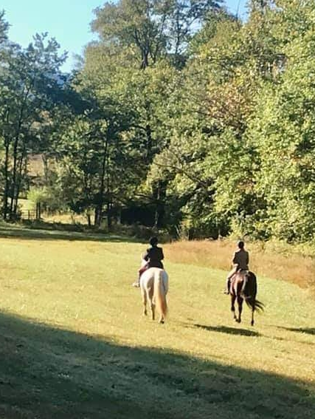 | Join us on a 7 mile ride across the rolling hills and wooded trails of Teatime Farm. The ride includes 6 judged trail obstacles. Divisions for Experienced, Novice, & Junior riders. Entry fee $40 for adults, $25 for juniors. This ride is the first in the Shenandoah Valley Judged Trail Ride Series. Riders who compete in all 4 rides will receive 10 bonus points towards the Championship.
For information, contact Susan Boone at boonesusan3@gmail.com
Enter online at https://orfhc.square.site/
Or visit www.oakridgefoxhuntclub.com
for entries and releases
Pre-registration is encouraged.
Proof of Negative Coggins is required.
Boots and helmets must be worn.

